Vedanta camp
by Swami Brahmavidananda and Swamini Brahmaprajnananda
19th – 25th February 2023
Rishikesh

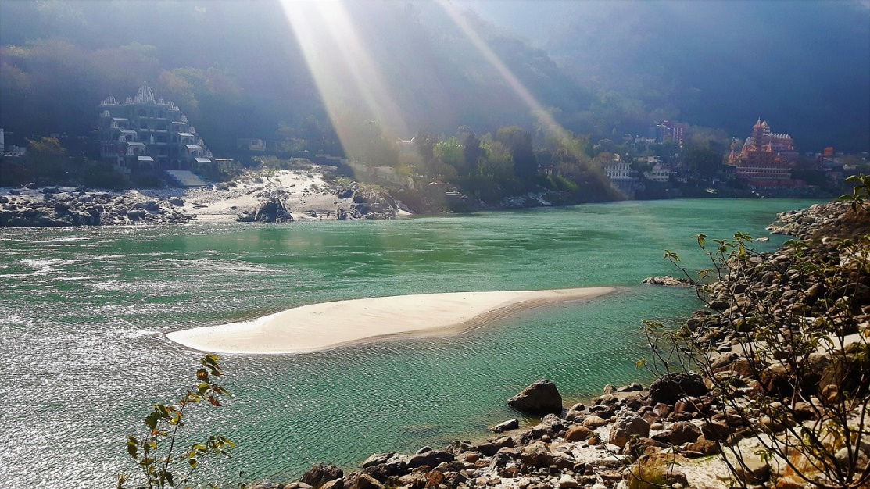

To learn Vedanta on the banks of the Ganga where many seekers and sadhus have done sadhana and gained self-knowledge is a blessing. To return to Pujya Swami Dayananda ji’s adhishthanam and seek his grace is a double blessing.

Dates for the Vedanta camp - 19th – 25th February 2023
The camp will begin on 20 th February, Monday at 9 am and will conclude on 24 th February, Friday 21.00/9 pm.
Participants are expected to arrive on 19 th February at the venue after 14.00/2 pm and can depart by noon on 25 th February, Saturday.

Topic and Eligibility: The classes will unfold the vision of Vedanta and will include sessions to enhance the preparedness or adhikaritvam of a student. The camp will include meditation in the classes. The texts to be taught in the camp will be provided to you or you will be requested, in advance, to bring the text with you.

Adults keen on self-knowledge and committed to participate in the entire camp are eligible for this and will benefit the most. If your children are accompanying you, kindly make arrangements for them in the room.

Location and accommodation:
We will stay at Ma Katyayani Mandir (Jnana Kartar Ashram) and Avadootwada Garbadaaseya Ashram also known as Pathi ji’s ashram. Both are less than a minute’s walking distance from our Swami Dayananda Ashram, Purani Jhadi, Rishikesh.
Accommodation is on twin sharing basis and in some cases on triple sharing basis. While our stay will be in these ashrams, classes will be in one of them - Ma Katyayani Mandir. All three meals (breakfast, lunch and dinner) will be served at our Swami Dayananda Ashram which is about a minute’s walking distance.

Donation - Rs 5000 per head ( includes stay and food for all days)
The donation to the ashrams includes your stay and three vegetarian meals on all days.
In case anyone is not able to afford the suggested donation, kindly write to us at vedantacamps@gmail.com, for us to look for sponsorship.

Since this is an ashram and not a hotel, kindly carry items of personal use. Blankets and linen are supplied by the Ashram. The time of our camp coincides with the end of winter and hence the maximum temperature is likely to be 24 degrees Celsius with day temperatures in the range of 14 – 24 degrees. The minimum temperature in the night drops to 9 degrees Celsius which will be only after 1 am when you are tucked away in your blankets. Please carry woolens and thermals accordingly.
The following items may be useful during your stay:
- Woolens
- Towels
- Flashlight (Torch)
- Insect repellent
- Medicines for personal use
- Chappals (Sandals)

Optional – The details of contributing to bhiksha at Swami Dayananda Ashram are here.

Daily Schedule:
5.30 – 6.45 am | Puja at the temple | 12.40 -1.30 pm | Lunch
7.00 - 7.30 am | Japa by the Ganga | 3.00 pm | Tea
7.40 – 8.30 am | Breakfast | 3.45 – 5 pm | Class
9.00 – 10.00 am | Class | 5 – 6 pm | Free time
10.15 – 11.15 | Class | 6 – 7 pm | Evening Aarati at temple
11.30-12.30 pm | Class | 7.15 – 7.45 pm | Dinner
 |  | 8 – 9 pm | Satsang

Transport:
The travel to Rishikesh and travel by road to the ashram is to be arranged by the participants. Taxis charge around Rs.800 to 1000 for a ride to the Ashram from the airport or from Haridwar railway station. You can also request for a taxi through Request a vehicle.

Registration:
To ensure your place in the camp, register soon by sending an email to vedantacamps@gmail.com with the following details:
Name,
Age,
City
Phone numbers, Phone number of next of kin
Arrival date and time
Departure date and time.
Donation transaction number

For Indian transfers only
Please transfer the amount of Rs 5000 via netbanking to
Aarsha Vidya Foundation’,
SB:000401143148,
IFSC – ICIC0000004.
or cheque in the name of ‘Aarsha Vidya Foundation’.

For international transfers

For participants from overseas, please transfer 70 USD to additionally account for Paypal fees https://paypal.me/SwaminiB

The last date for registration is 1st February 2023.

Refunds and cancellations-
In the event of your cancellation, the amount will be non-refundable but considered towards your participation in the next camp.

For further queries kindly write to us at vedantacamps@gmail.com

